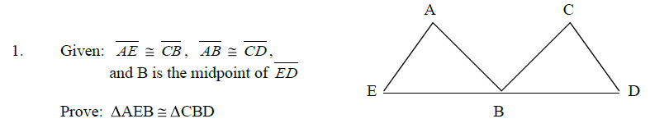
Statement | Reason
AE ≅ CB, AB ≅ CD, B is the midpoint of ED | Given
EB ≅ DB | Reflexive Property
ΔAEB ≅ ΔCBD | SAS

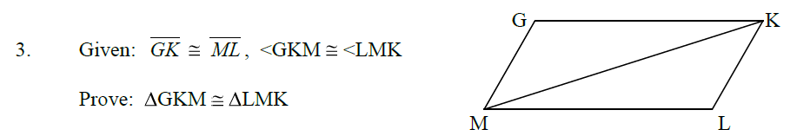
Statement | Reason
GK ≅ ML, ∠GKM ≅ ∠LMK | Given
MK ≅ MK | Congruent
ΔGKM ≅ LMK | SSA

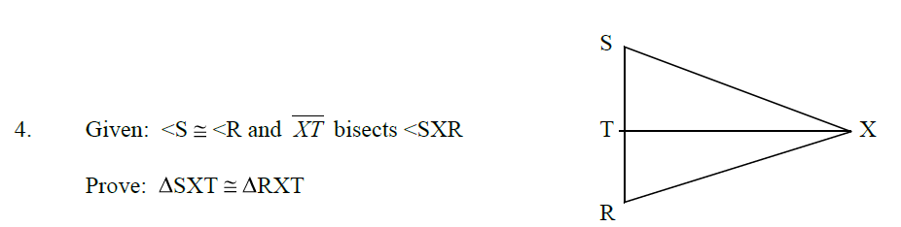

Statement | Reason
∠S ≅ ∠R, XT bisects ∠SXR | Given
∠SXT ≅ ∠RXT | Reflexive Property
XT ≅ XT | Congruent
ΔSXT ≅ ΔRXT | SSS

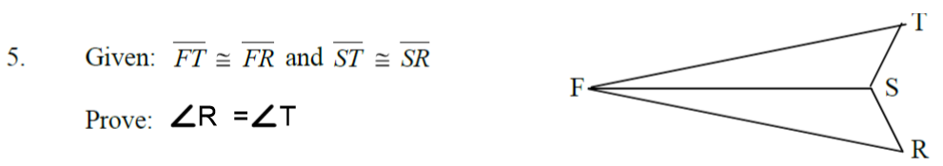
Statement | Reason
FT ≅ FR, ST ≅ SR | Given
∠TFS ≅ ∠RFS | Reflexive Property
ΔTFS ≅ ΔRFS | SAS
∠R ≅ ∠T | Corresponding Parts of ≅ Triangles are ≅

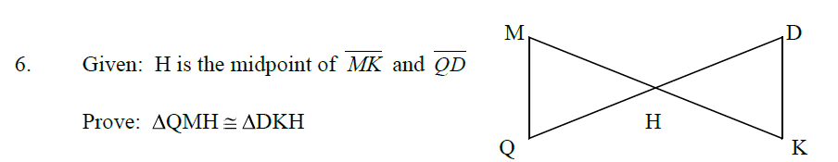
Statement | Reason
H is the midpoint of MK and QD | Given
MH ≅ HK and QH ≅ DH | Definition of Bisect
∠MHQ ≅ ∠DHK | Reflexive Property
ΔQMH ≅ ΔDKH | SSA
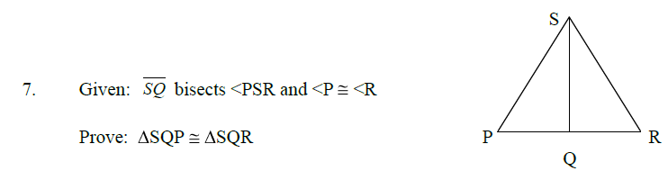
Statement | Reason
SQ Bisects ∠PSR and ∠P ≅ ∠R | Given
∠PQS ≅ ∠RQS | Definition of Bisect
∠PSQ ≅ ∠RSQ | Reflexive Property
ΔSQP ≅ ΔSQR | AAA
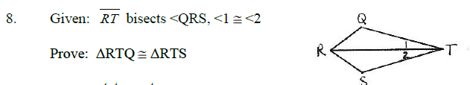
Statement | Reason
RT bisects ∠QRS, ∠1 ≅ ∠2 | Given
∠QRT ≅ ∠SRT | Congrunet
∠Q ≅ ∠S | Reflexive Property
ΔRTQ ≅ ΔRTS | ASA
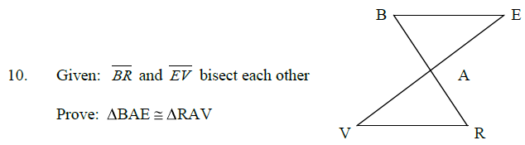
Statement | Reason
BR and EV bisect each other | Given
BA ≅ RA and VA ≅ EA | Definition of Midpoint
∠BAE ≅ ∠RAV | Corresponding Angles
ΔBAE ≅ ΔRAV | SAS
Statement | Reason
∠2 ≅ ∠3 and ∠1 ≅ ∠4 | Given
∠B ≅ ∠D | Reflexive Property
ΔABC ≅ ΔCDA | AAS

